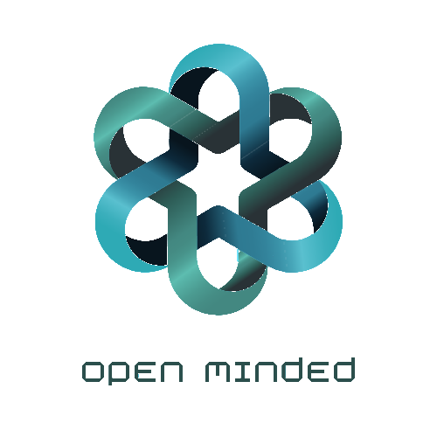­­

Съдържание

**Team1**

Members2

Roles3

**Въведете заглавие на главата (ниво 1)4**

Въведете заглавие на главата (ниво 2)5

Въведете заглавие на главата (ниво 3)6

1.Team

|  |  |  |
| --- | --- | --- |
| **#** | **Name** | **Role** |
| 11 | Ivo Badalov | Scrum Trainer |
| 22 | Georgi Ivanov | Back-End developer |
| 33 | Teodor Tanev | Front-End developer |
| 44 | Simeon Syarov | Quality assurance engineer |

2.Introduction

* Product

The games is about…………The target of the game is to make people feel relaxed and play it so they can enjoy their time spent with the game. Also, it can be used at primary schools to test student’s knowledge in a different and interesting way.

* Where is it available?

You can find our collaborative work in GitHub. Files are accessible to everyone by the GitHub Repository we created about our project.

* Communication

We communicated through Microsoft Teams. This platform is the best talking to communication about working in team. Thanks to all features we easily contacted each other and helped ourselves.

* Used technologies

The technologies that we used are Visual Studio 2022 as an integrated development environment. C++ as a programming language. Microsoft Word for the documentation, Microsoft PowerPoint for the presentation, GitHub for collaborative work.

1. **Methods and manners of implementation**

* Task alignment

Each person is assigned a task in which he does well to complete the task to the best of his ability

* Terms

Observance of dates was reminded by the Scrum Trainer. A meeting of the team is held when everyone is online to discuss the amount of time needed to complete the assigned task.

* Productive work

The tasks are defined in a way that everyone is aware of the tasks performed so far.